**1.Introduction**

**1.1 Overview**

**General elections were held in India in seven phases from 11 April to 19 May 2019 to elect the members of the 17th Lok Sabha. Votes were counted and the result was declared on 23 May. The election resulted in a landslide victory for the BJP which won 303 seats and formed the government.**

**1.2 Purpose**

**The election resulted in a landslide victory for the BJP which won 303 seats and formed the government. Around 912 million people were eligible to vote, and voter turnout was over 67 percent – the highest ever, as well as the highest ever participation by women voters.**

**2. Problem Defin­­­­ition & design Thinking**

**2.1 Empathy Map**

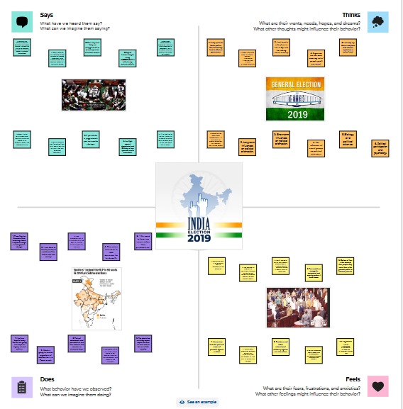

**2.2 Ideation & Brainstoraming Map**

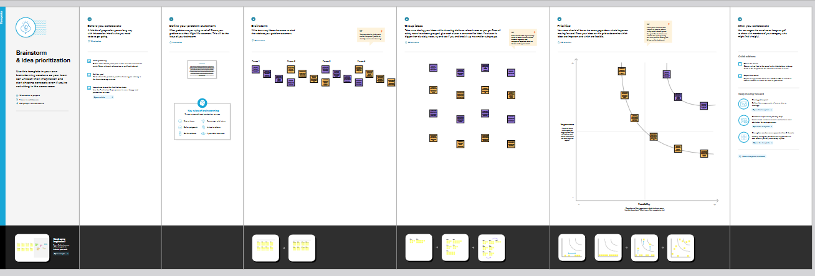

**3.Result**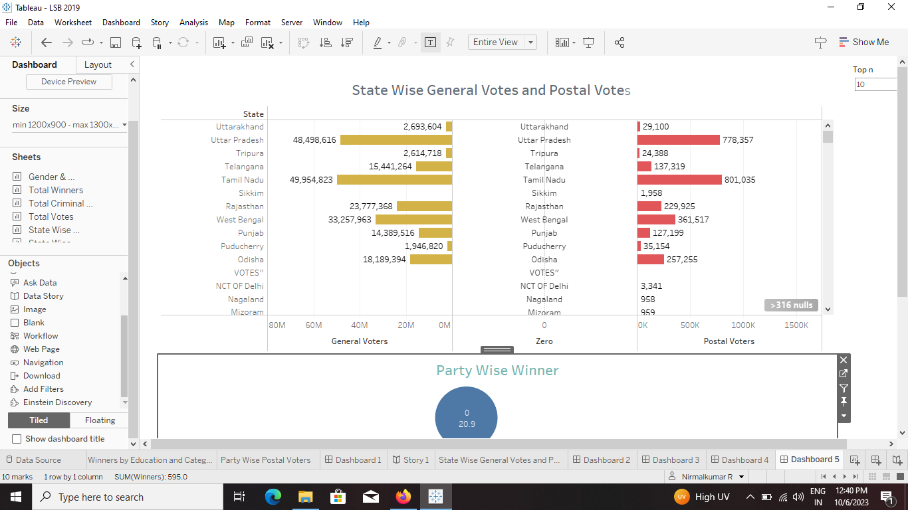

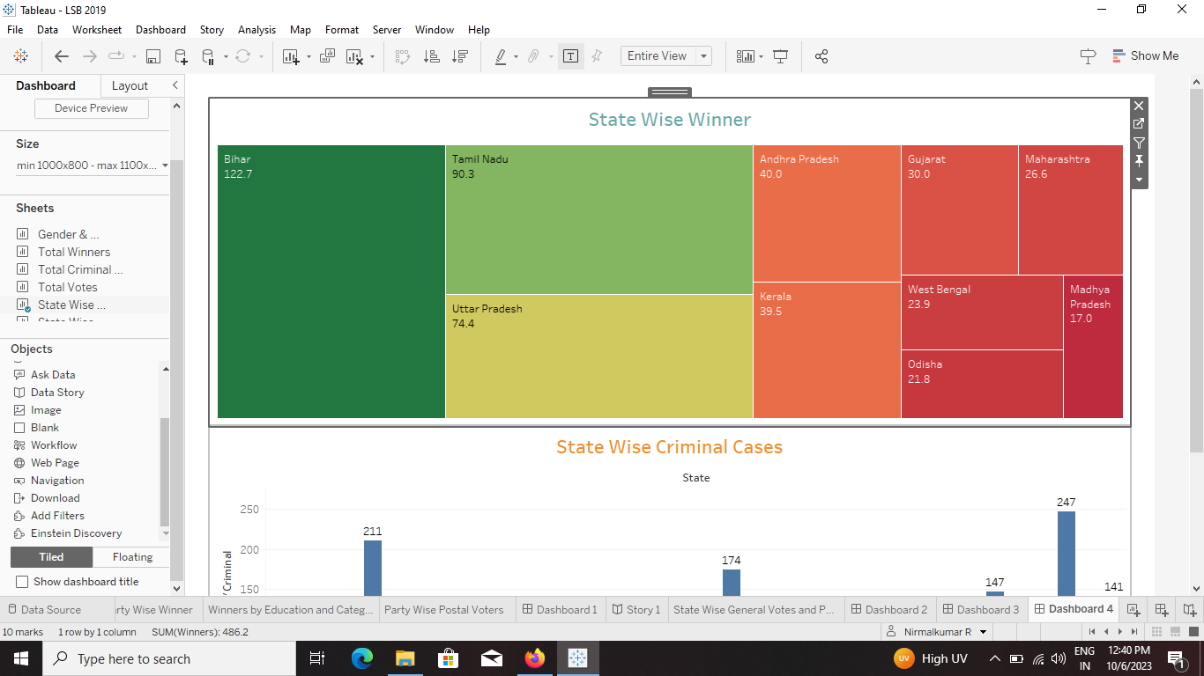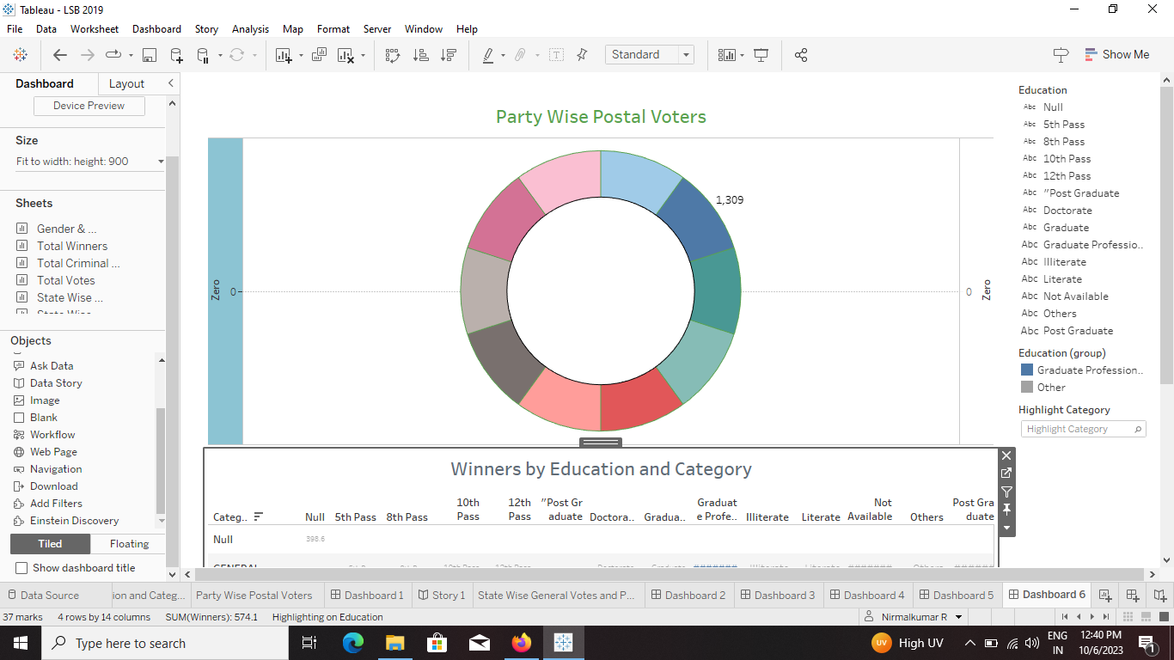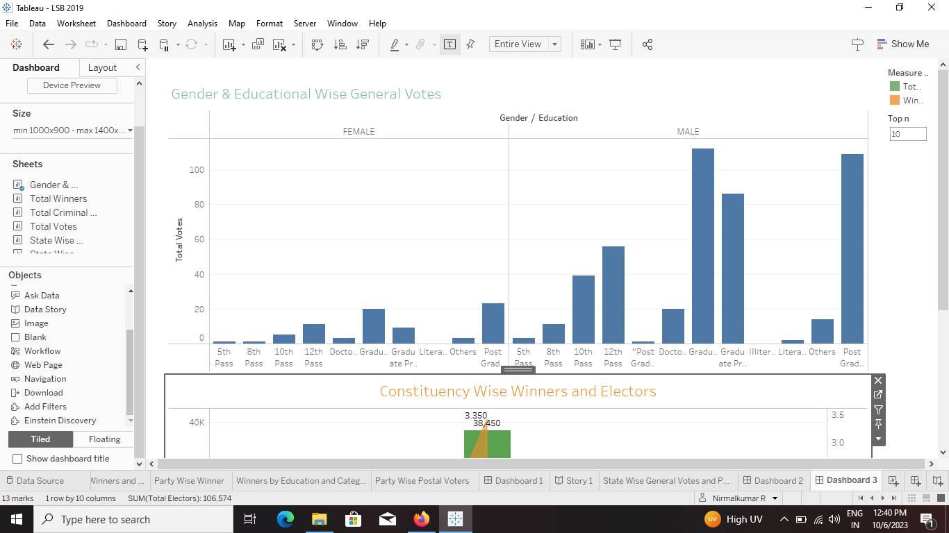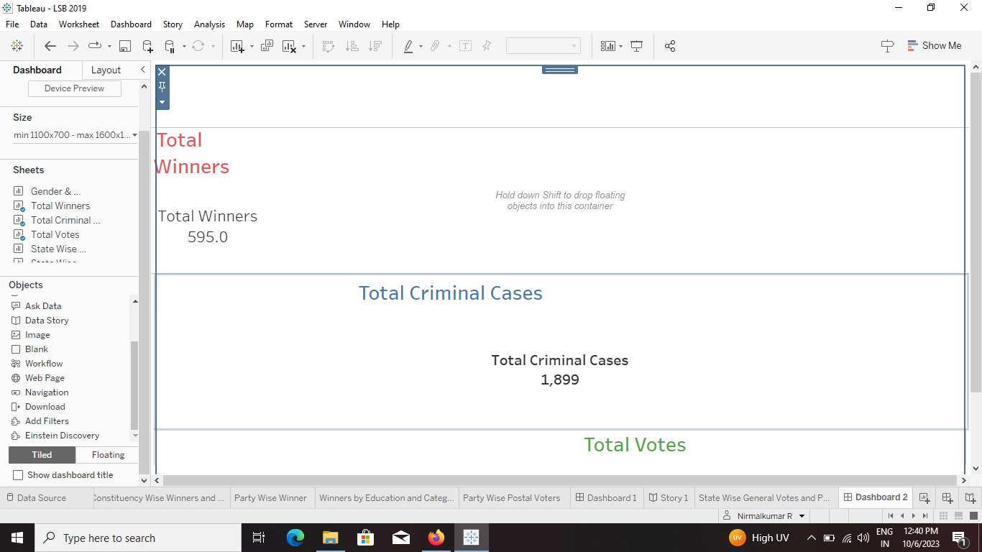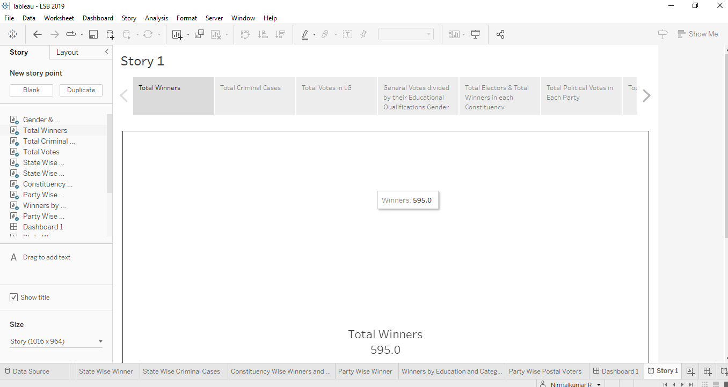

**4.Advantages & Disadvantages**

**4.1 Advantages**

**It helps in proper functioning of democracy through the system of checks and balances. No confidence motion can only be introduced and passed in the Lok Sabha. So, it controls the despotism of the government. Money bills can be only introduced in the Lok Sabha.**

**4.2 Disadvantages**

**The Congress party campaign highlighted "agrarian distress" as an election issue. The BJP campaign highlighted that the Congress party had been in power for five generations of the Nehru dynasty and its past promises and campaign issues have been empty.**

**5.Applications**

**General elections were held in India in seven phases from 11 April to 19 May 2019 to elect the members of the 17th Lok Sabha. Votes were counted and the result was declared on 23 May. The election resulted in a landslide victory for the BJP which won 303 seats and formed the government.** **BJP's sitting MP from Navsari CR Patil, who was seeking re-election from the seat, has registered the highest victory margin in the 2019 Lok Sabha elections. He defeated his nearest Congress rival DB Patil by a record 6.89 lakh votes.**

**6.Conclusion**

**Voter turnout of 7th phase estimated till 8 pm- Total 62.87%; Bihar-53.36%, Himachal Pradesh- 69.73%, Madhya Pradesh-71.44%, Punjab-62.45%, Uttar Pradesh-57.86%, West Bengal- 73.51%, Jharkhand-71.16%, Chandigarh-63.57%. On Sunday in the seventh and the final phase of the Lok Sabha election held in 59 constituencies across eight States and Union Territories nearly 61% voters turned out to cast their vote. Voting took place in Punjab, Uttar Pradesh, West Bengal, Bihar, Madhya Pradesh, Himachal Pradesh, Jharkhand and Chandigarh. Besides the Lok Sabha seats, by polls were held four Assembly seats in Tamil Nadu and one in Goa.**

**7.Future Scope**

**The next Indian general election is expected to be held in India between April and May 2024 to elect the members of the 18th Lok Sabha.** **Prime Minister Narendra Modi-led National Democratic Alliance (NDA) may score a clear majority with 315 seats in a House of 543, if Lok Sabha elections are held now, says India TV-CNX Opinion Poll projection, final results of which were telecast on the news channel today.**

**The Congress-led opposition combine I.N.D.I.A may get 172 Lok Sabha seats, and 'Others' including regional parties and independents, may get 56 seats, according to the projections.**

**The ruling Bharatiya Janata Party's (BJP) strength in Lok Sabha may get reduced from 303 to 293 this time, says the India TV-CNX Opinion Poll. On the other hand, the main opposition party Congress which has 52 seats, may increase its tally this time to 70, according to the projection.** **Bharatiya Janata Party, formed the union government, with Narendra Modi continuing as Prime Minister.**